Re-wilding our Parish Field.
Yes this is Jane – Jane Harnett. She is the driving force behind both the re-wilding the parish field project and also the Best Kept Village Competition. She is also a parish Councillor and a village hall trustee. This is what she has to say about the environment:
Those of us who are of a certain age will recall how essential windscreen wipers were on dark dry summers evenings. After only a few minutes driving vision obliterated by hundreds of splattered insects and moths. Although mass murder of insects on this scale wasn’t something to celebrate at the time, it can be used as a measure to highlight the worrying decline of the UK’s insect population, now put at a 65% loss.
The Reality is humans have, and continue to, destroy precious habitats, use pesticides and pollute the atmosphere!
An estimated 118,000miles of hedgerows have disappeared since the 1950’s.
Many humans alive today have never even seen what true countryside looks like. Humans have managed and shaped land longer than any of us reading this have lived.
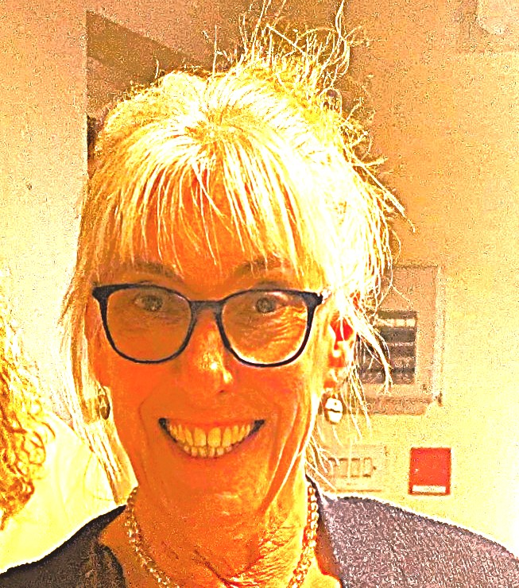
Alarmingly it has been estimated one mouthful of food in three is supplied and helped to grow by pollinators.
Please say Hello to Jane
Over the past century rural landscapes in Britain have become increasingly dominated by large expanses of monoculture. Without a mixture of habitat and food sources, rural areas can sometimes be little better than green deserts for biodiversity. Studies conclude that some urban areas have a more diverse insect population thanks to private gardens providing all round food and habitats.
Research has highlighted the need for more joined-up corridors of land including farms, parks, and private gardens across the UK, providing all round food supplies and better habitats for insect populations to grow.
Local authorities are also encouraged to do their bit to give a little land back to nature. Stafford was awarded bee friendly town status last year. A particularly successful group called Rising Brook Ground Force has worked hard to re wild a large area of land beside the busy A449.
Re wilding is the best way to improve the health of pollinating insects and biodiversity.
It is for all these reasons and after a deal of consideration, seeking advice from Staffordshire wildlife, attending re wilding courses, joining supportive societies and listening to our community, Stowe By Chartley parish council are delighted to support a project to re wild small areas of the parish field.
The intention is to gradually introduce new flowers and to leave certain areas of grass to grow longer with mown pathways leading through to the children’s play area. The longer areas of grass will be left long until a date before the fete when it will be cut flat. Mowing this way will not harm our rewilding efforts at all, in fact cutting the grass like this helps to spread seeds ready for the next season and is advised by leading experts in wild meadow management.
On March 22nd this year, a group of volunteers, armed with their trowels, gloves and for some, kneeling pads, met at the parish field to plant 150 wild flower plug plants. Most were varieties suitable for planting under hedgerows, trees or in clay soil. (See the accompanying list and map.) Weekly visits to check on their progress is planned to try and prevent the little plants being overwhelmed by nettles and to ensure that as many of them as possible thrive. We are reliably informed not to expect flowers until their second year.
Expectations should be realistic. Humans tend to have a romantic image of wild meadows, perhaps one filled with 90% colourful flowers as per the front of a seed packet. Generally, without a ridiculous amount of time and energy from dedicated people, this is not the case. Usually, areas left to nature are filled with grasses, leafy plants and a few flowers which like the soil and the position of the land.
It will be exciting to see what happens, but we have to be patient. What grows this year could be very different the next. Some years we may have flowers and then others none. Some of us might love the new wild look, others might prefer a manicured lawn. What really matters is Stowe By Chartley is doing our bit to encourage a healthy planet, and we might just begin to notice more butterflies and bees in our own gardens.
The plan is to plant spring flowering bulbs some time in the Autumn.
If you would like to become part of the re wilding volunteer group, please contact Jane Harnett at cllrjharnett@stowe-by-chartley.gov.uk

