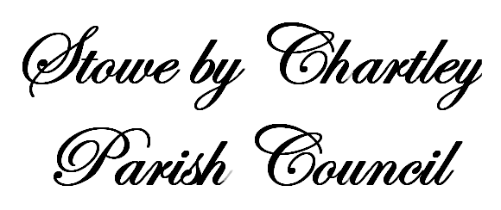


You are summoned to an ordinary meeting of the Parish Council which will be held at 7.00 p.m. on Thursday 27.3.2025 in Stowe Village Hall. An agenda for the meeting is shown below.
Signed: 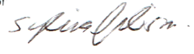
Mrs S Gibson 21/03/25

N.B 1. This meeting will be recorded. The recording will be destroyed as soon as the minutes have been approved by Councillors

AGENDA

46/25 To receive apologies for absence and to approve reasons for absence

47/25 To receive Declarations of Interest on any item on the agenda

48/25 To receive applications for Dispensations under the Localism Act 2011

49/25 To adjourn the meeting for Public Participation

